This document covers navigating the Client Portal from the client’s point of view. Each of the five available portal components is addressed. If your agency opts not to enable every component, you may want to edit this document or otherwise communicate the features available to your client.

Some thought should also be given to how the client is provided the login Username credential. As soon as App Access is granted from the Clients menu header, the password email reset is sent. This email provides the link to reset the password but does not contain the Username for security purposes. Once the password is reset, the client is redirected to the portal login page. Login instructions are included below and assume that the client’s portal Username is their email address. This example should be reviewed and updated to match your agency’s requirements.

Accessing the Client Portal
Client Portal access is enabled for your account and a password Reset email from noreply@echoman.com is already on its way. Follow the instructions within the email to reset your password. We recommend bookmarking this page for easy access in the future. If you forget, you can always find the link on our website or by entering the following address in your browser’s address bar www.myagency_echoehr.com/portal. An example of the password reset email is provided below.
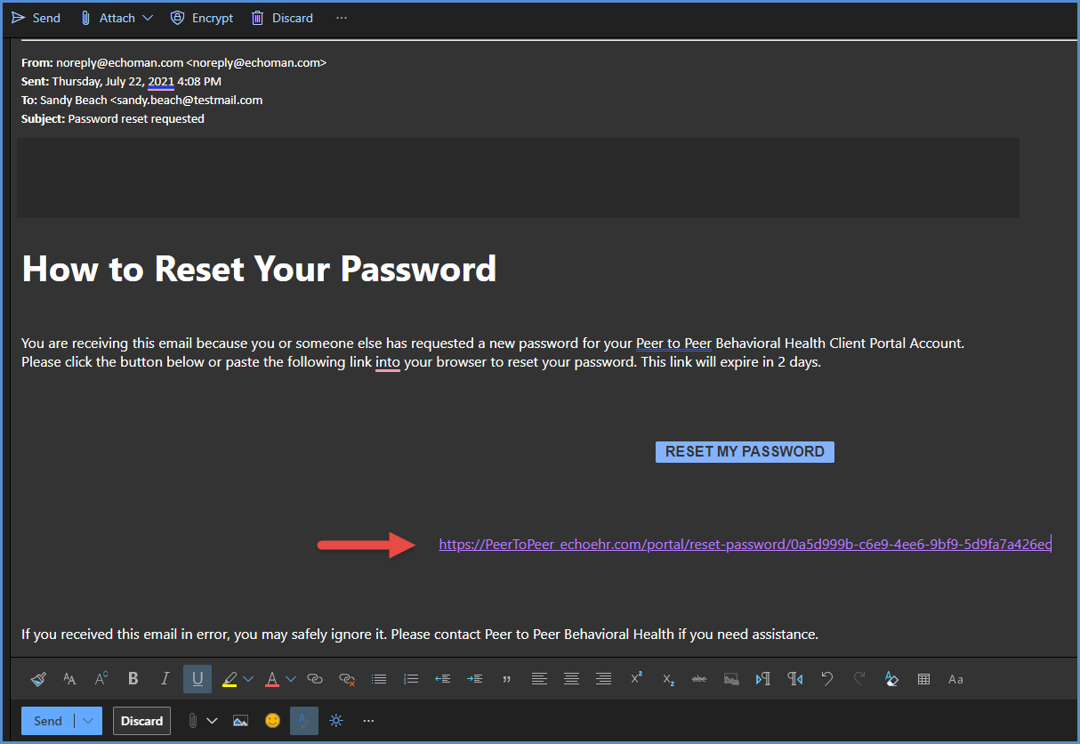
Once complete, you are redirected to the portal login page. Enter your email address as the Username and then your newly created Password. Select the blue LOGIN button.
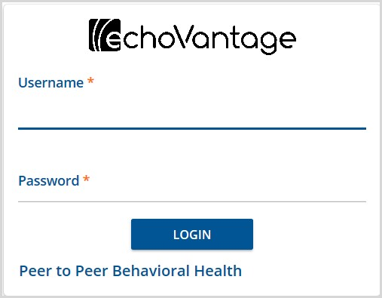

Navigating the Client Portal
Once logged in, the screen defaults to the Home page. The menu on the left indicates the features enabled. The white “cards” in the main body of the screen contain summary information for each menu item and the VIEW ALL option links to the detail page of the corresponding item. In the example below, the five available features are enabled.
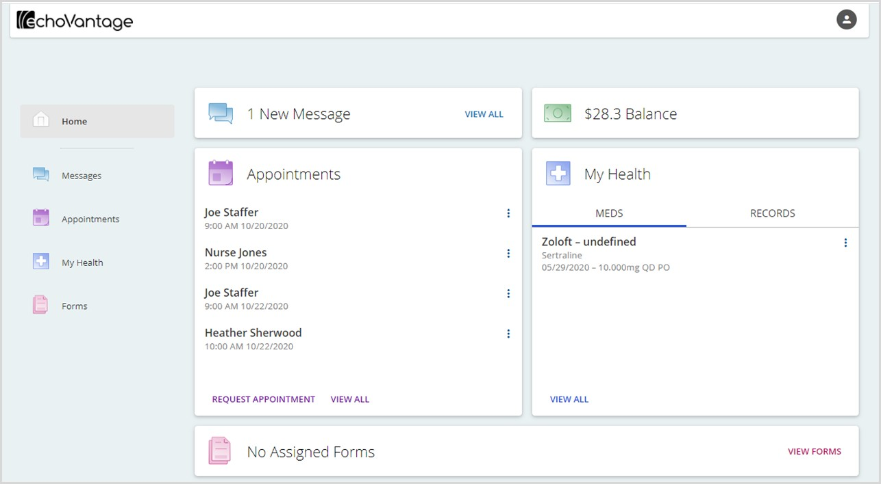
Currently, the Balance card is summary balance information only. There are no additional details to view and no link in the left-hand menu. Client Payments and Unapplied Payment amounts are not reflected in the Balance total until they are processed.

Messages
The Messages card displays a count of new direct messages, if any. Clicking on View All or selecting Messages from the left-hand menu displays the details for All Messages.
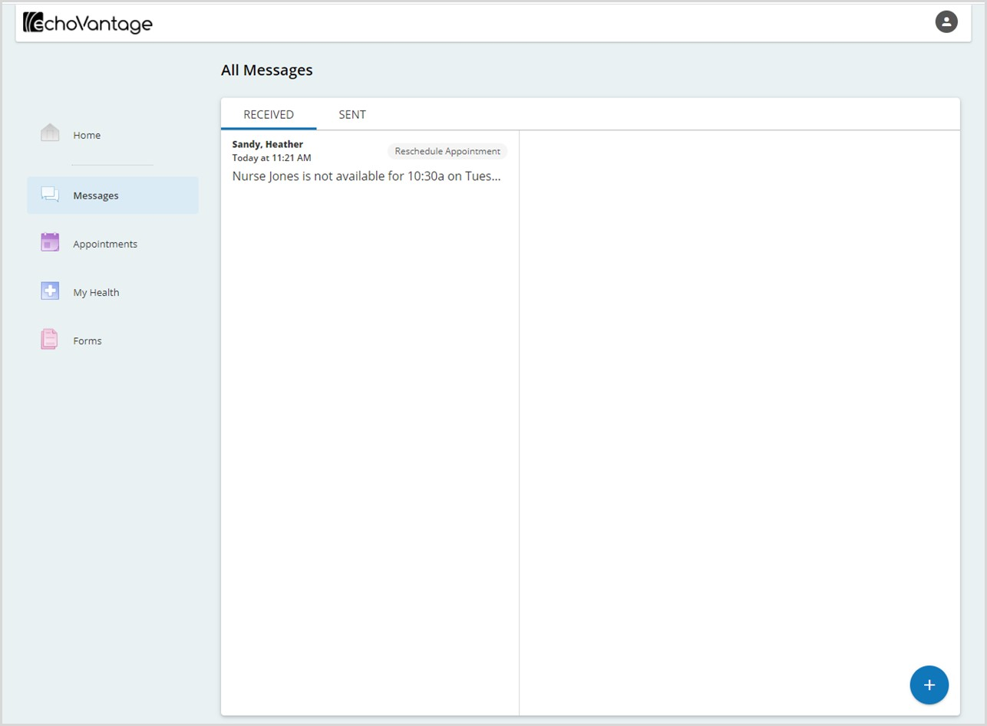
Messages are divided into two tabs, RECEIVED and SENT, and navigating and interacting with the messages is the same in both tabs. These messages are direct messages between the Group Mailboxes configured in EchoVantage and your Client Portal account - Staff and Client email addresses are not used. Predefined subject titles are used to ensure the message is routed to proper recipient.

- A card displays for each message with summary information.
  - The first names of the sender and recipient are listed in bold.
  - The date and time the message was sent or received displays beneath the names.
  - The predefined message subject is listed to the right with a gray background.
  - A preview of the message body shows beneath the date and time.
- Click anywhere on the message card to view the full details.

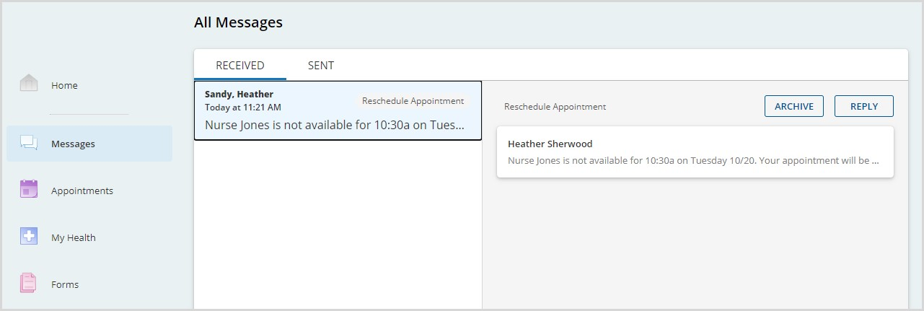
- The full message displays in the right-hand pane.
- Select the REPLY button to respond to the email.
  - A card displays beneath the original message.

- The full message displays in the right-hand pane.
- Select the REPLY button to respond to the email.
  - A card displays beneath the original message.
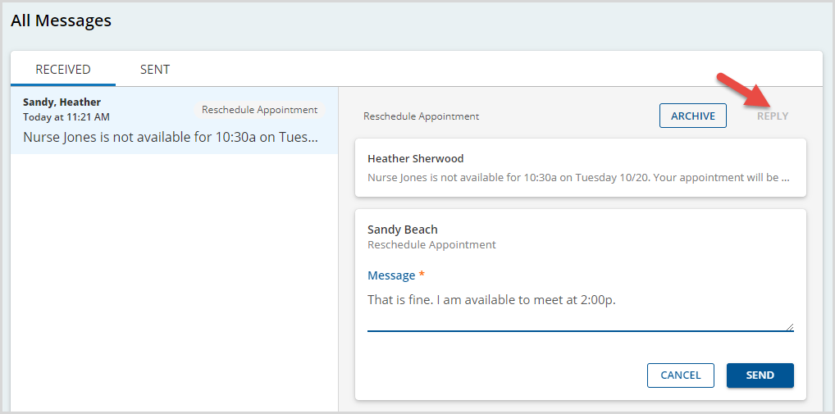
  - Enter the response text in the Message field.
  - Select SEND to complete the reply.
- Select the ARCHIVE button to remove the message from the list permanently. Archived messages are deleted permanently.
- After new messages are viewed, the New Messages count is updated (after a polling interval) on the home screen. If there are no new messages, the card indicates this, as shown in the image below.

Appointments
The Appointments summary card displays any scheduled or requested appointments. Clicking on an appointment opens the details of that appointment on the scheduled tab of the details screen. Several additional actions are available from the summary card on the Home page.
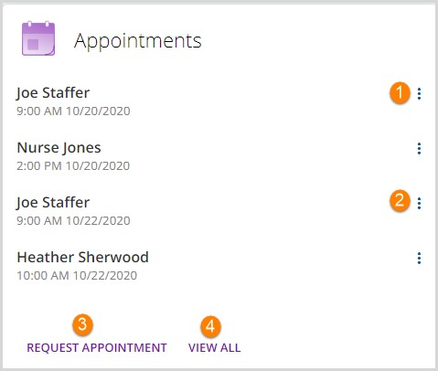
1. When the current time is within 48 hours of the scheduled appointment, options are available to Confirm or Update the appointment.
- To confirm an appointment, click on the ellipsis (three dots) and click Confirm.
- An indicator displays for confirmed appointments.
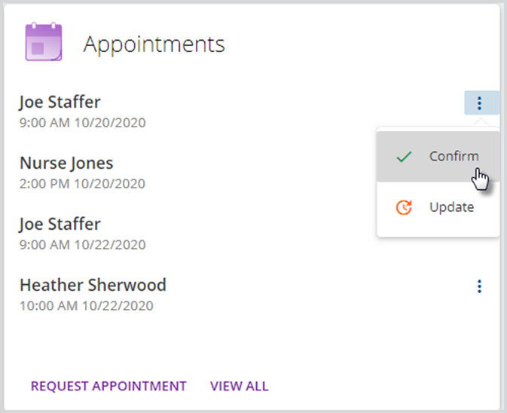 | 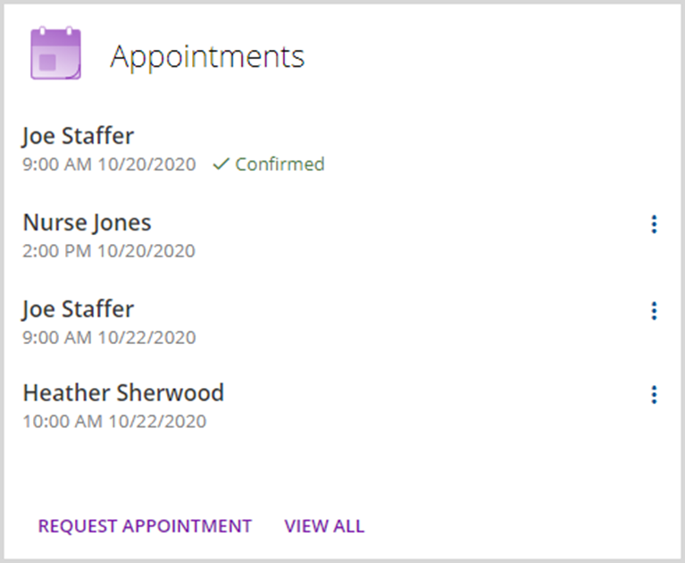

- To update an appointment, select the Update action after clicking on the ellipsis.
    - An Update Appointment box displays, shown below.
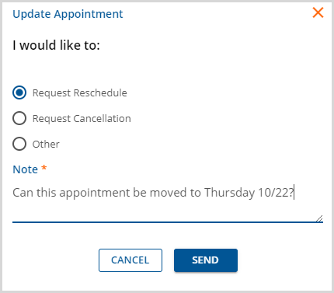
    - An update reason must be selected, and a Note is required.
    - On SEND, the update reason is indicated in the summary unless Other was selected.
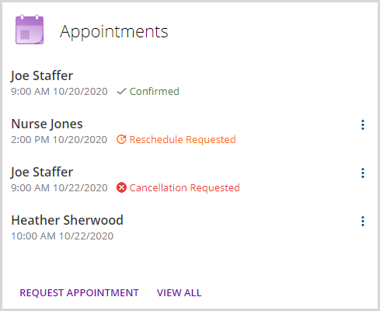

2. When the current time is more than 48 hours in advance of the appointment, only the Update option is available when the ellipsis is selected.
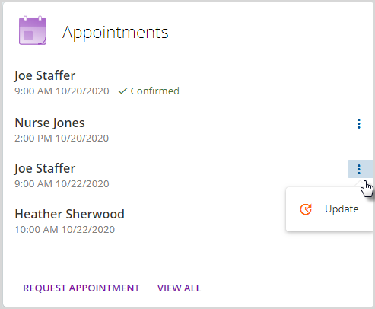

3. Click on Request Appointment to create a new appointment request.
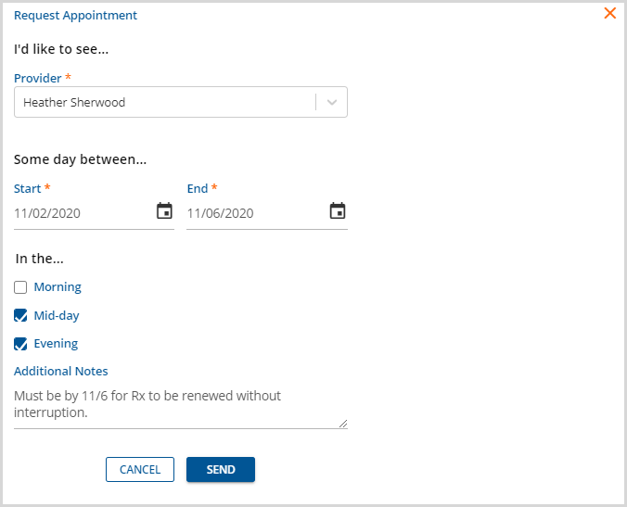
    - Select at least a Provider name and Start and End Dates.
    - Time of day and Additional Notes are optional.
    - Select SEND to complete the appointment request.

4. Clicking VIEW ALL opens the Appointments detail screen. This screen is divided into two tabs.
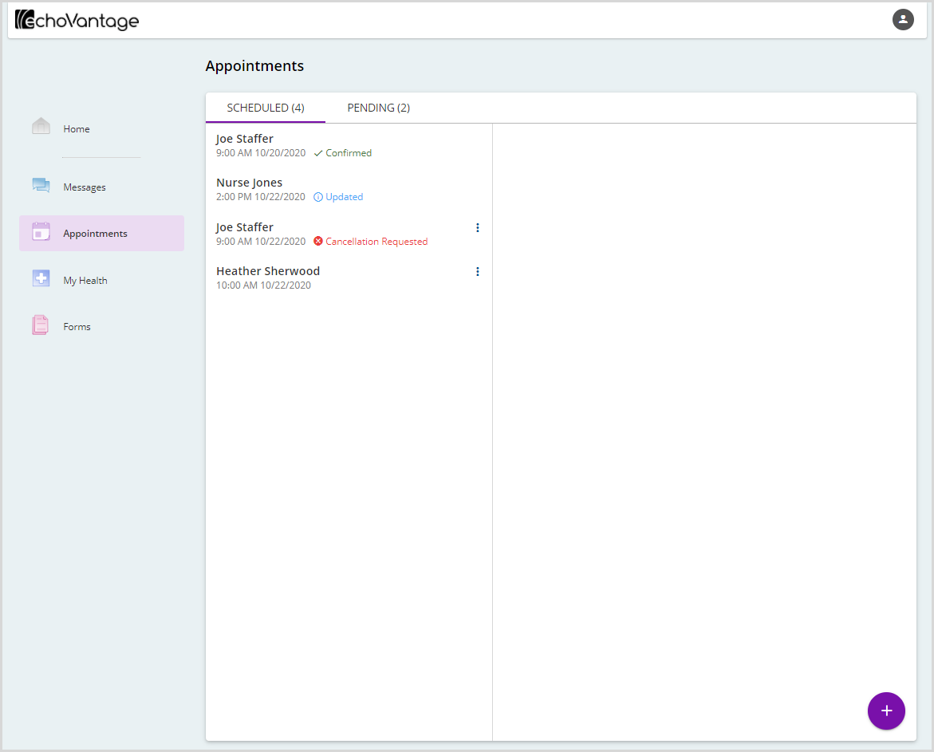
- SCHEDULED – Lists all currently scheduled appointments with the current count.
  - These are the same appointments listed on the Home screen summary card.
  - The same actions are available when the ellipsis (three vertical dots) is selected.
    - Update only if more than 48 hours from scheduled appointment
    - Confirm if within 48 hours of scheduled appointment
  - Request a new appointment by clicking on the purple plus “+” sign. The same Request Appointment screen covered in #3 above is opened.

- PENDING – Lists any pending appointment requests and a count of new or unaddressed requests.
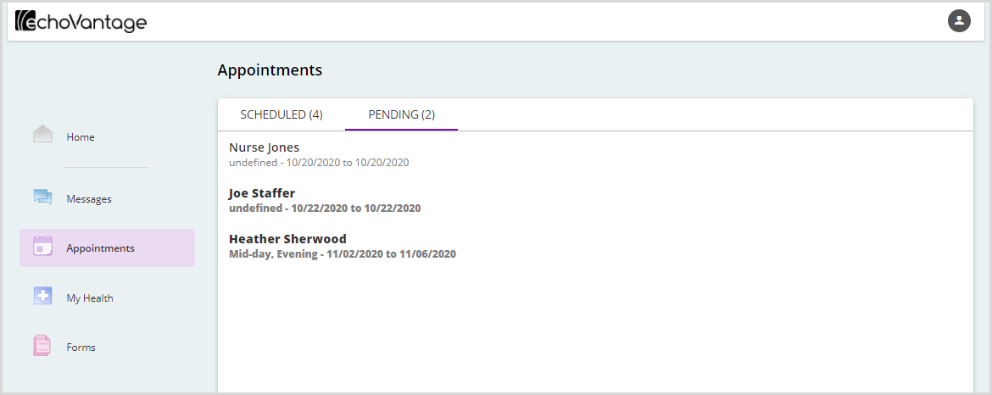
- This tab displays pending new appointment requests and update requests, like a reschedule or cancellation.
- A Pending request displays in bold until the agency responds to the request.
- After the agency updates the request,
  - It is no longer bold.
  - And the Scheduled tab is updated appropriately.
    - A new appointment was added.
    - Or an existing appointment was updated or canceled.
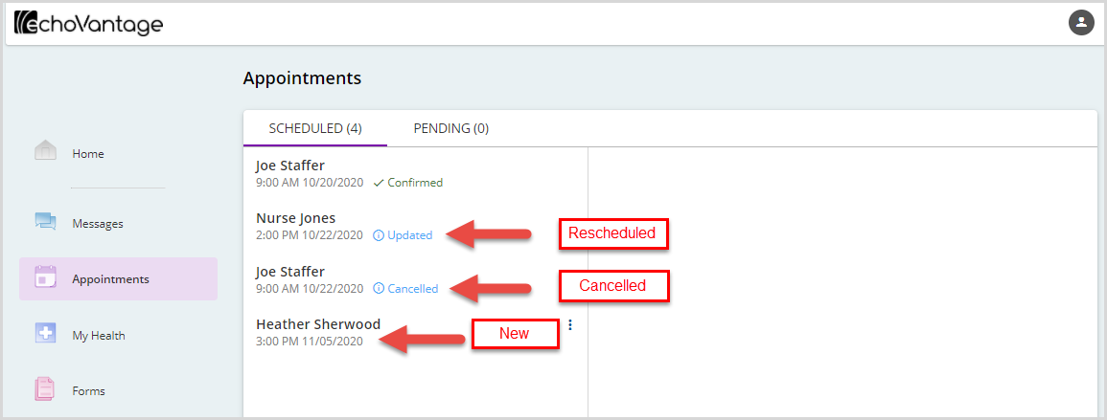
- Clicking on any appointment on the SCHEDULED tab displays the details of that appointment in the right-hand pane.
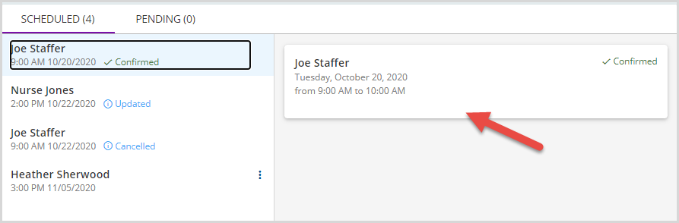

My Health
The My Health card on the Home screen displays summary medicine (MEDS) and clinical health record (RECORDS) information.
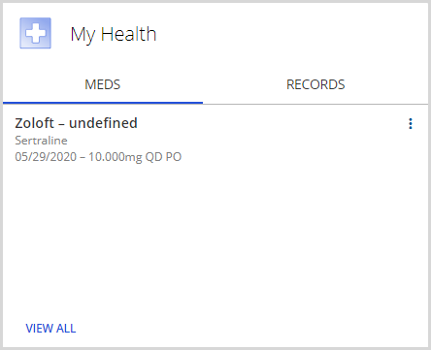
- Only active medications are listed on the summary card.
- Click on VIEW ALL to view all medications including inactive ones.
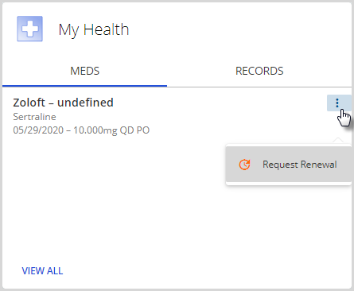
- Click on the ellipsis (three vertical dots) to start the Request Renewal process.
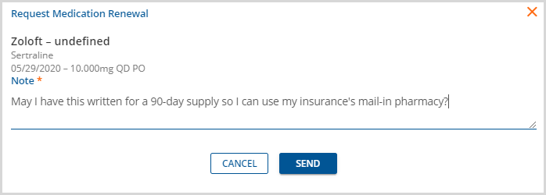
- Once SEND is selected, a Renewal Requested message displays beneath the medication.

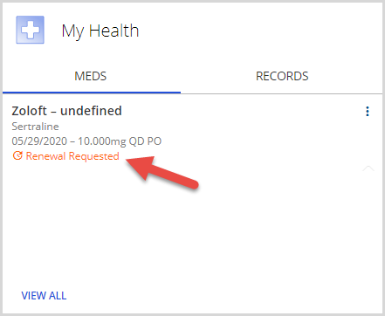

In the RECORDS section of the summary card,
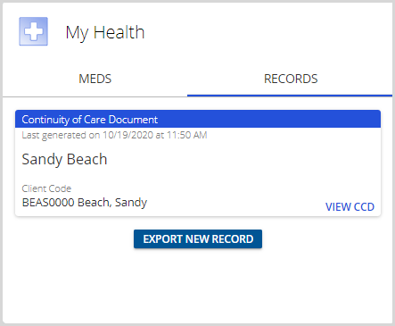
- The most recently generated CCD, Continuity of Care Document, is displayed.
- A CCD is the term used for an electronically generated, client-specific clinical summary document.
- Click on the blue VIEW CCD to view the full details of the Continuity of Care Document.
- A new CCD export record can be created by selecting the blue EXPORT NEW RECORD button.

The details screen for the My Health menu option contains the same information and available actions as the summary screen and lists inactive medications.
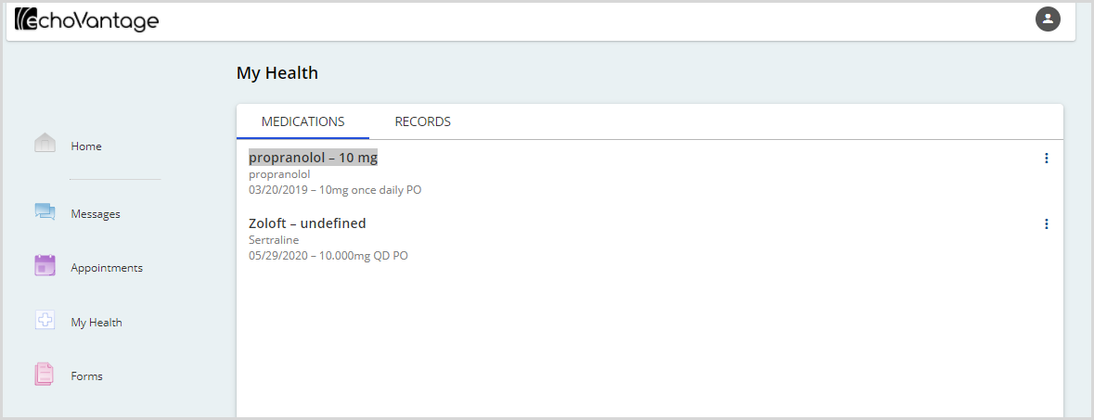

Forms
If Forms are shared with the Client Portal, they show as assigned forms on the Forms summary card along with a count. Click on the Forms menu item or on the red View Forms to view, complete, and sign Forms.
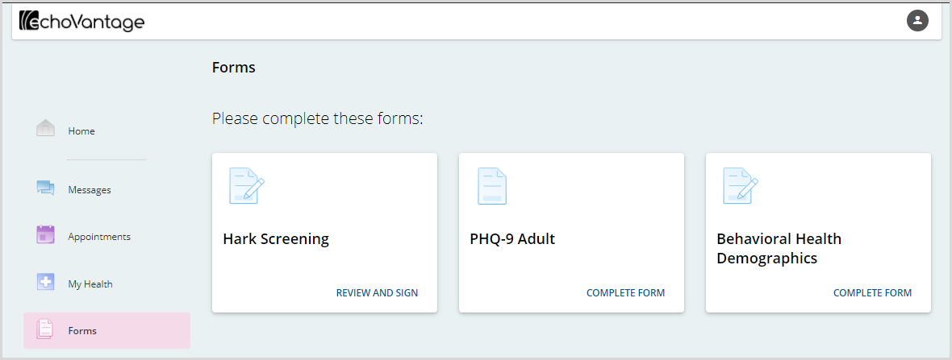
- A card displays for each form that was shared to the Client Portal.
- The button in the bottom-right corner grants access to each form, and also describes the expected action(s):
  - Complete Form
  - Review Form
  - Sign Form
  - Review and Sign Form

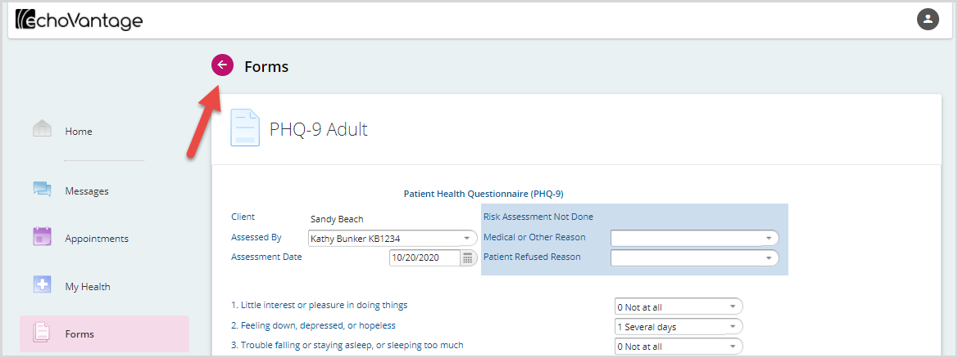
- When all required actions are completed on a form, the action buttons, Save or Cancel, are disabled. Select the magenta left arrow at the top to return to the assigned forms.
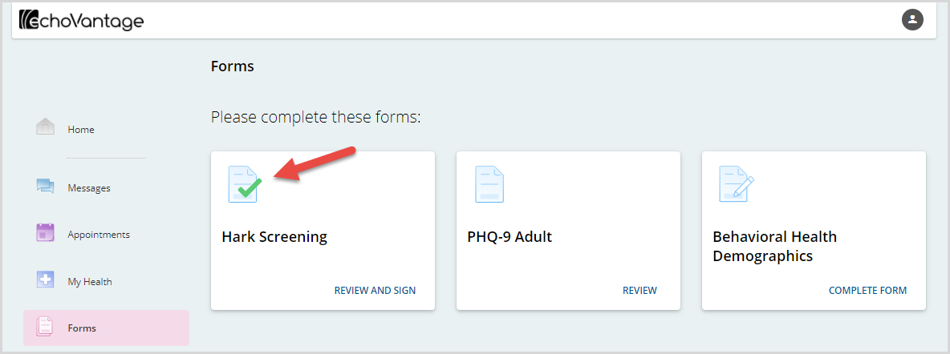
- As forms are completed, a green check mark indicates progress.
- Keep in mind that once a form is signed, no further changes can be made.
When the Forms are cleared and nothing is shared, the summary card returns to the No Assigned Forms state.

